**Evidence for Analysis and Design Unit.**

Ewa Lipinska

Cohort E20

**A.D.1 Use case Diagram**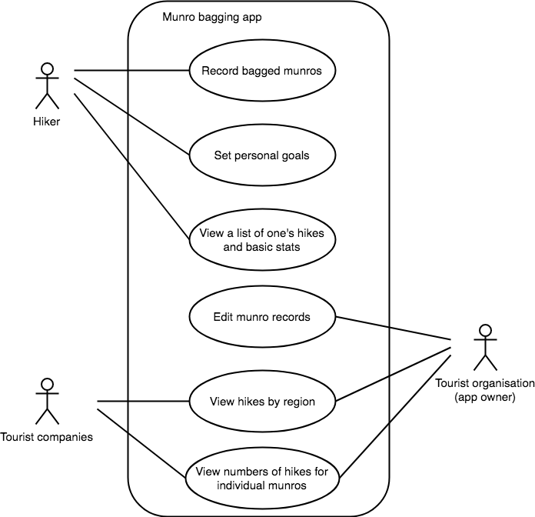

**A.D.2 Class diagram**

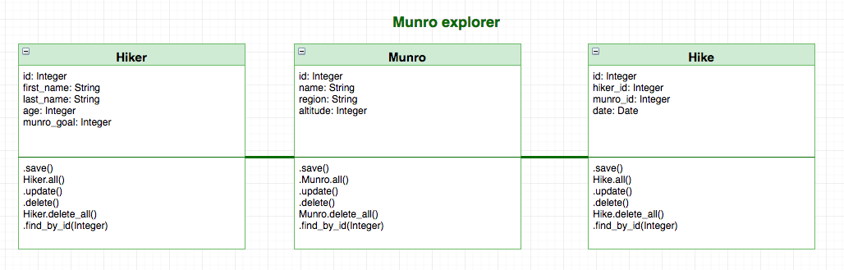

**A.D.3 Object diagram** 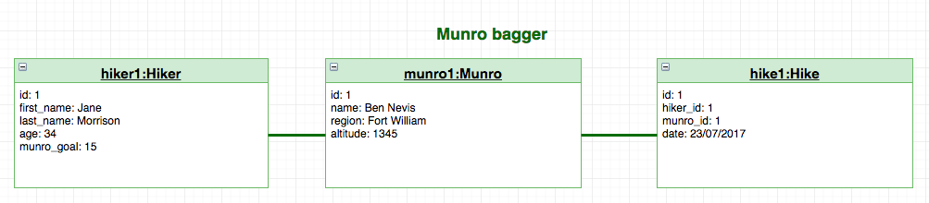

**A.D.4 Activity diagram**

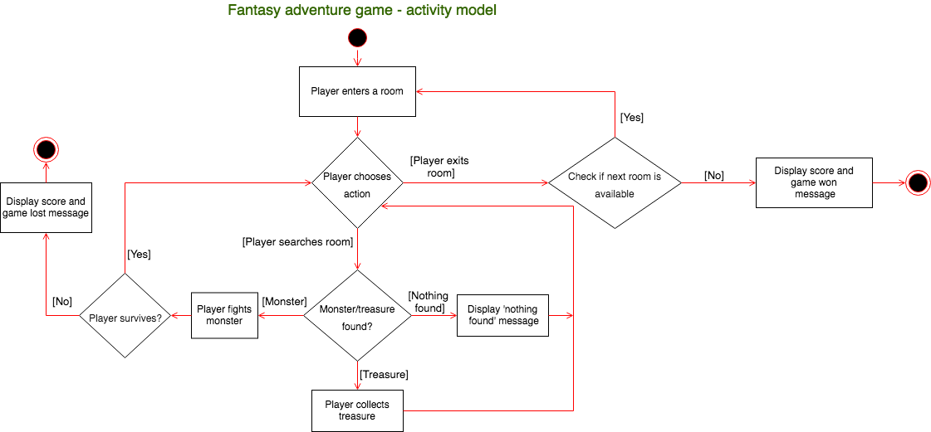

**A.D.5 Inheritance diagram**

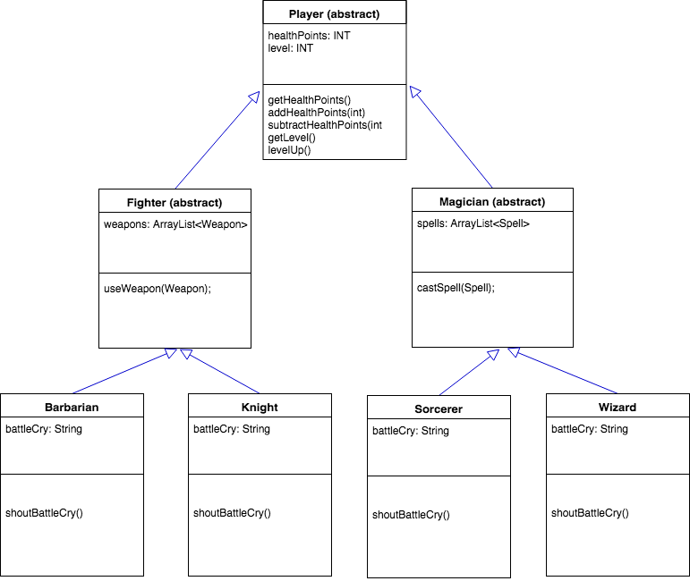

Evidence for unit

**A.D.6 Implementations Constraints**

|  |  |  |
| --- | --- | --- |
|  | **Constraint and possible effect** | **Solution** |
| **Hardware and software platforms** | The app looks good in the browser on a number of screen sizes, but is overfilled with text on mobile. | Create a simplified layout for mobile devices. |
| **Performance requirements** | As the number of records in the app’s database grows, it might take more time for pages to load. | Add a visual progress indicator for the user, review SQL queries for possible improvements. |
| **Persistent storage and transactions** | Heroku’s Postgres plan is limited to 10 000 rows in database – this could become an issue with an increased number of users. | Watch the number of registered users and upgrade the plan if necessary. |
| **Budgets** | The app uses Heroku’s free Postgres plan, which puts restriction on the database capacity and app usage. | Look for an alternative database service or allocate funds to pay for one of Heroku’s paid plans. |
| **Time** | The project had to be built in 7 days (including planning, coding and testing), so the functionality is fairly basic and there was little time to implement user feedback. | On the ‘About’ page, indicate that this is a basic version of the app and invite user comments so that the product can be improved in the future. |